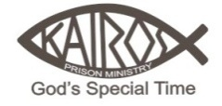
KAIROS ADVISORY COUNCIL NORTHEAST CORRECTIONAL COMPLEX
APRIL MINUTES (April 19th, 2025)

Attending:
Harry Ennis, Jared Malone, Scott Hale, Jody Mims, Greg Watlington, Dean Yates

Excused:

Call to Order
Scott opened the meeting at 9:00 AM.

There was not a quorum of Advisory Council members in attendance.

No official business was transacted and no minutes taken.

A discussion of Kairos 45 ensued to ensure everything is in place to begin the weekend on Thursday, April 24th.

The next Advisory Council meeting is scheduled for May 17th.

Respectively submitted,

Tom Egan, Secretary

Tom

